Task 1: Identify Network Configuration Using ipconfig /all

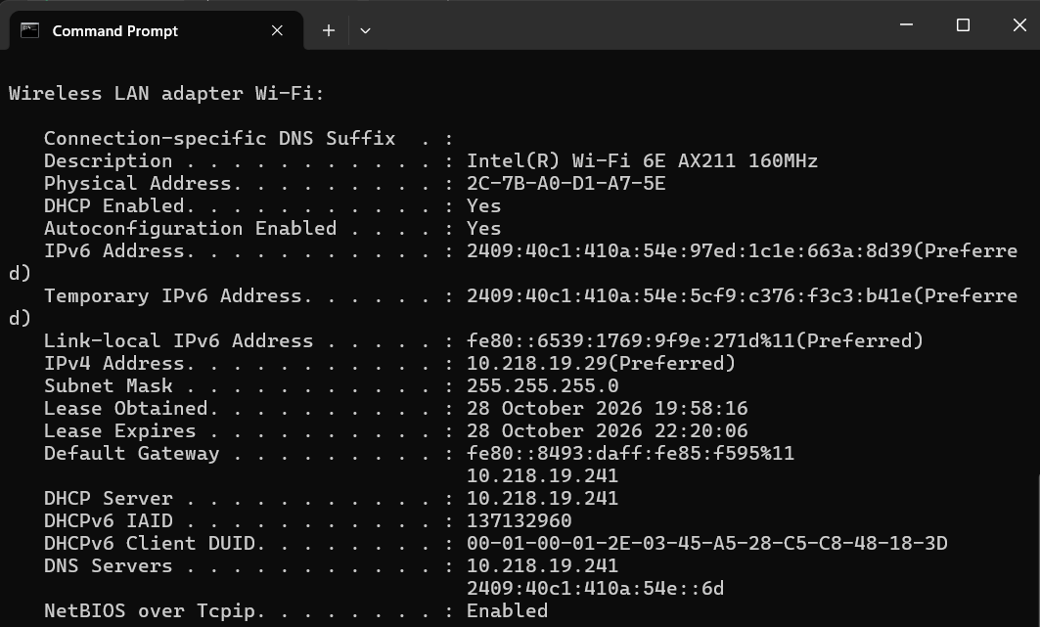

Task 2: Test Connectivity Before and After Disconnecting the Network

Command: ping www.google.com
A. Before Disconnecting Wi-Fi
Output:
Reply from 142.250.183.36: bytes=32 time=25ms TTL=117
Reply from 142.250.183.36: bytes=32 time=27ms TTL=117
Reply from 142.250.183.36: bytes=32 time=24ms TTL=117
Reply from 142.250.183.36: bytes=32 time=26ms TTL=117
Result: The computer can reach Google's server, and the replies indicate successful connectivity.
B. After Disconnecting Wi-Fi
Output:
Pinging www.google.com [142.250.183.36] with 32 bytes of data: General failure.
Request timed out.
Result: The computer cannot successfully complete the ping test.
What each status means for your note:
- Reply from ... time=XX ms: the destination is reachable and the round trip took XX ms. Replies with 0% loss mean a healthy connection.
- Ping request could not find host: the name could not be resolved to an IP address. With no network, the laptop can’t reach a DNS server, so this points to a DNS or no-connection problem.
- General failure: the laptop itself has no working network connection, for example the adapter is off or disconnected.
- Request timed out: packets were sent but no reply came back. The link or a device along the path is down, or something is blocking the replies.
- Destination host unreachable: no route to the destination, so the laptop or a router along the way can’t deliver the packets.

Task 3: Monitor Network Usage While Streaming YouTube

Process | Network Usage
Google Chrome | 8.5 Mbps
WhatsApp Desktop | 0.2 Mbps
Other Applications | 0.1 Mbps
Result: Google Chrome uses the most network bandwidth because it is streaming the video.

Task 4: Wireshark Packet Capture & HTTPS Filtering

Three types of information you can see in the filtered packets:
- Source and destination IP addresses and ports (e.g. your IP to a server on port 443), which tell you who is talking to whom.
- TLS handshake details: the server name (SNI) such as the site’s domain, the TLS version and the supported cipher suites. Open a “Client Hello” packet and expand the TLS section to see them.
- Packet metadata: timestamps, packet sizes and TCP flags (SYN, ACK, FIN), which show when connections open and close and how much data moves.
For plain HTTP packets (if captured any), can also see the request method (GET or POST), the URL path, headers such as Host and User-Agent, and the response status code (e.g. 200 OK). With HTTPS, the page content is encrypted and not readable, which shows why HTTPS protects users. Don’t share the capture file publicly.

Task 5: Troubleshooting Checklist for Slow Internet While Gaming

AI-Generated Network Optimization Checklist
1. Switch from Wi-Fi to a Wired Ethernet Connection: Connect your gaming PC or console directly to the router using a Cat6 Ethernet cable to eliminate wireless interference, packet jitter, and micro-drops.
2. Move to the 5 GHz or 6 GHz Wi-Fi Band: If wired connection is impossible, disconnect from congested 2.4 GHz bands and connect to the 5 GHz (or 6 GHz) band to reduce interference from household appliances.
3. Enable Quality of Service (QoS) on Your Router: Configure QoS settings in your router's admin panel to prioritize gaming traffic packets over background downloads or video streaming streams.
4. Change DNS Servers to High-Performance Public Resolvers: Switch your default ISP DNS to fast resolvers like Cloudflare (1.1.1.1) or Google (8.8.8.8) to speed up initial game server domain resolution times.
5. Restart Your Network Hardware (Power Cycle): Unplug both your ISP fiber modem/ONT and Wi-Fi router for 60 seconds to clear corrupted cache tables, flush bufferbloat, and re-establish a fresh ISP session.
First Suggestion I Would Try
I would first connect the gaming computer directly to the router using an Ethernet cable.

